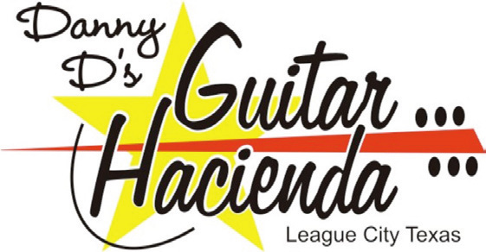

“the songwriters”® contest entry form
- The Winner and Runner-up have videos on line for a voting forum.
- The Finalists are collected for a showcase and finalist concert @ The Texas Song Fest April 28th 2012.
- One winner gets a lot of Toys, Equipment, Recording Time, Record Release and Management

First Name: ________________________________

Last Name: ________________________________

Your Name as you would like it published in print:

Print Name:___________________________________________________

Your name as it appears on your ID: _______________________________

Birth date: _____________________________________________________

Address : ___________________________________________________

City : ________________________St: ____ Zip: ______________

T-Shirt Size :__________

Email : ___________________ Phone : _______________________

Instrument you’ll be playing:
Acoustic Guitar  Electric Guitar  Keyboard  Other 
If your instrument is an “other”, you better bring your own “other.”

Rules:
1) Your song must have a name/title.
2) Your song must have a melody
3) Profanity will disqualify your entry
4) Unsigned artist only
5) Plagiarism will not be tolerated
This may sound basic, but you would be surprised what we get
6) Song must be 4 minutes or less

Title of your song: _____________________________________________

MP3   CD    Inquire about alternative submission media
$20 DOLLAR ENTRY FEE MUST ACCOMPANY EACH SONG.
Entries not chosen for the next semi-final round receives a $20 Guitar Hacienda Gift Card
Cash, money order or credit cards accepted at store locations.
All contestants will be required to sign video release for website and television.

